Assessment Schedule – 2014

Calculus: Apply integration methods in solving problems (91579)

Evidence Statement
Q1 | Expected Coverage | Achievement  u | Merit  r | Excellence  t
(a) | 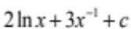 | Correct integral.
(b) | 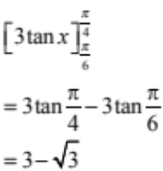 | Correct solution with correct integral.  Accept 1.27  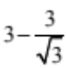
(c) | 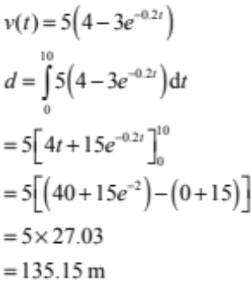 | Correct integral. | Correct integral and correct solution.  Units not required.
(d) | 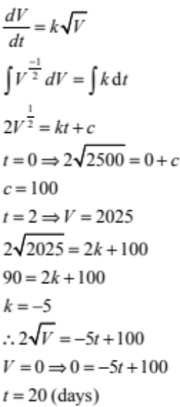 | Correct integral  (3rd line). | Correct solution with correct Integral.  Units not required.

(e) | 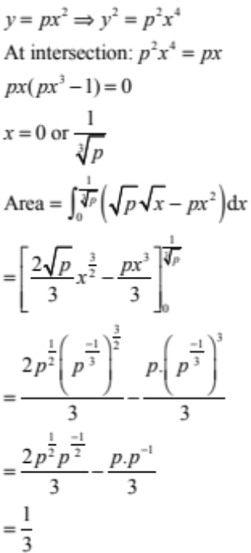 |  | Correct integral. | Correct solution with correct integral.

NØ | N1 | N2 | A3 | A4 | M5 | M6 | E7 | E8
No response; no relevant evidence. | ONE answer demonstrating limited knowledge of integration techniques | ONE correct integration | 2u | 3u | 1r | 2r | 1t with minor errors ignored | 1t

Q2 | Expected Coverage | Achievement | Merit | Excellence
(a) | 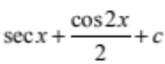 | Correct integral.
(b) | 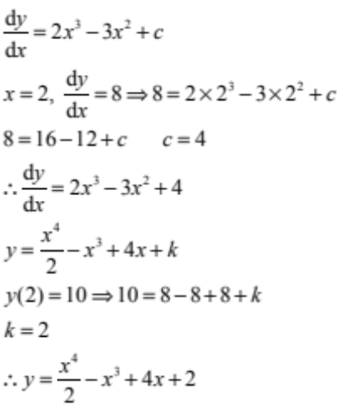 | Correct solution with correct integrals given.
(c) | 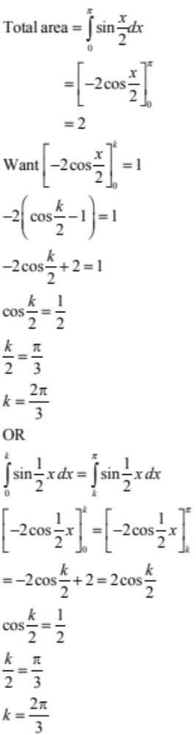 | Correct total area with correct integral.  OR  Correct 3rd line in alternative method. | Correct solution with correct total area and correct integral.
(d) | 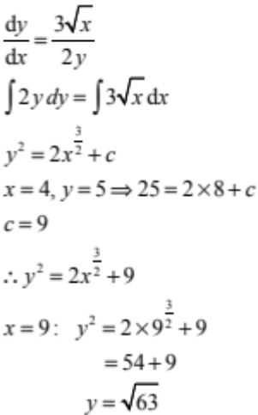 | Correct general solution. | Correct solution.
(e) | 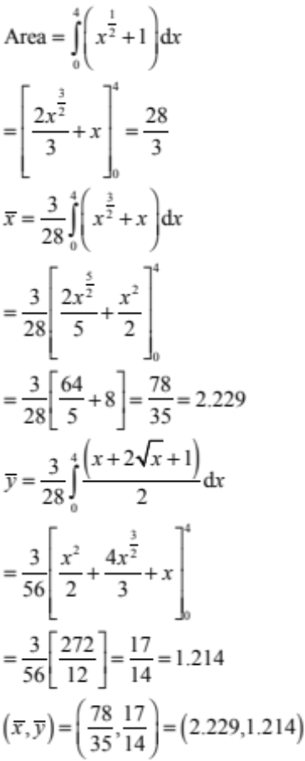 | Correct area with correct integration. | Correct area with correct integration and 1 correct coordinate. | Correct area with correct integration and 2 correct coordinates.

NØ | N1 | N2 | A3 | A4 | M5 | M6 | E7 | E8
No response; no relevant evidence. | ONE answer demonstrating limited knowledge of integration techniques | ONE correct integration | 2u | 3u | 1r | 2r | 1t with minor errors ignored | 1t

Q3 | Expected Coverage | Achievement | Merit | Excellence
(a) | 5 | Correct solution.
(b) | 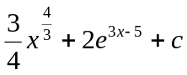 | Correct solution.
(c)(i)  (ii) | 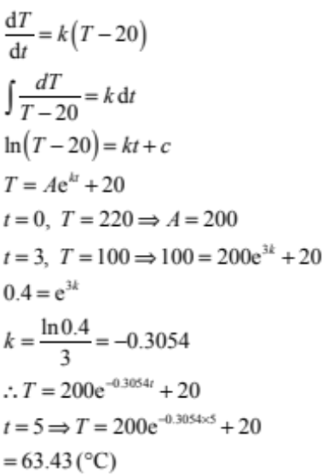 | Correct DE and correct general solution (3rd line). | Correct DE, correct general solution and correct answer.  Units not required.
(d) | 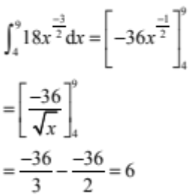 | Correct integration. | Correct integration and correct solution.
(e) | 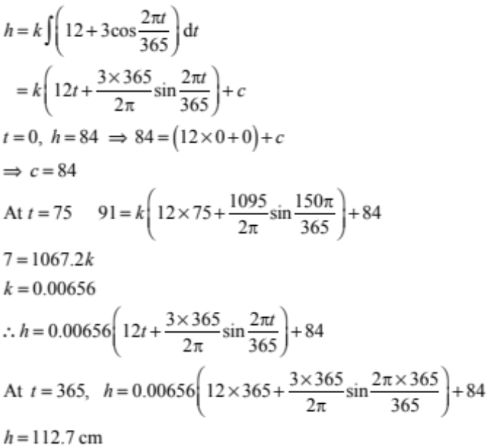 | Correct integration. | Correct integration and correct values of the constants. | Correct integration, correct values of the constants and correct solution.

NØ | N1 | N2 | A3 | A4 | M5 | M6 | E7 | E8
No response; no relevant evidence | ONE answer demonstrating limited knowledge of integration techniques | ONE correct integration | 2u | 3u | 1r | 2r | 1t with minor errors ignored | 1t

Cut Scores
 | Not Achieved | Achievement | Achievement with Merit | Achievement with Excellence
Score range | 0 – 6 | 7 – 12 | 13 – 19 | 20 – 24

